Emergency Ambulance Services Committee
Register of recommendations from Audit Reports
EASC Governance Arrangements
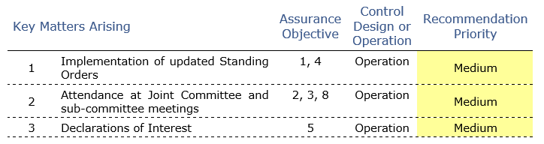

 | Recommendation | issue | Priority | Completion by | Lead | Progress | Completed
1 | Implementation of updated model standing orders | 1.1 Further work should be prioritised to implement the remaining actions required to ensure EASC is compliant with the adopted model Standing Orders. | Med | July 2022 | GR | The work on the adopted Model Standing Orders will be completed, presented and approved by EASC.  Updated list developed and attached | On target
 |  | 1.2 Updates on progress to implement the outstanding actions should be reporting to the relevant committee for monitoring. | Low | July 2022 | GR | Outstanding actions will be initially reported at the EAS Joint Committee and following at the next Audit and Risk Committee meeting. Appendix 1  On target | On target
2 | Attendance at Joint Committee and subcommittee meetings | The importance of attendance at Joint Committee and sub-committee meetings should be re-emphasised collectively and should be followed up with those who regularly miss meetings. | Med | July 2022 | GR | The Chair of the Committee and sub-committees will write to members in relation to meeting attendance by health board or NHS Trust representation. Attendance information will be included in the Committee and sub-committee annual reports. | On target
3 | Declarations of interest | 3.1 The list of people required to make a declaration of interest should be reviewed for completeness and then completed declarations should be obtained from all. | Med | July 2022 | GR | The Committee Secretary will review the table of declarations of interest for completeness and will obtain responses from all and present to the EASC.  Completed and online | Completed
 |  | 3.2 The EMRTS sub-committee should require members to make or confirm any declarations of interest at the start of each meeting. | Low | Completed | ME | Completed, added to the Agenda for the EMRTS DAG in December and ongoing | Completed  Dec 2021

