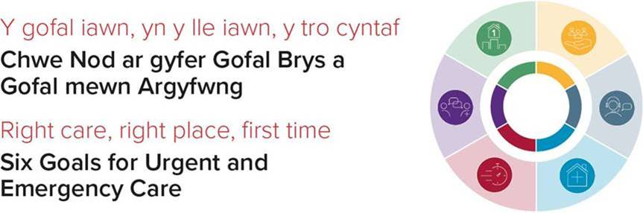

Project Group: ECNS Implementation Group / EASC

Proposal Title: ECNS implementation and optimisation

What did we do in 2021 / 22 (leave blank if new project?) Funded the initial procurement and year 1 implementation costs

Goal / project / area of investment that links to this project:
Primary benefits to Goal 4: Rapid response in physical or mental health crisis

The procurement and implementation of this system is referenced within the Six Goals for Urgent and Emergency Care policy handbook as a key deliverable of the programme in 2021/22

Secondary benefits to Goal 2: Signposting people with urgent care needs to the right place first time.

The complex nature of urgent and emergency care will mean some patients will access the 999 system for their urgent care needs, safe, effective and robust secondary clinical assessments services within the 999 system will ensure these patients are signposted and supported to access the right care.

and Goal 3: Clinically safe alternatives to admission to hospital

Safe, effective and robust remote clinical assessments services within the 999 that can harness the power of modern technology to provide care will enable patients to access safe alternatives without the need for an ambulance attendance.

What was your project? Procurement and implementation of the ECNS system
Following significant research and development with the International Academies of Emergency Dispatch (the provider of ECNS), they have sought to work with WAST, granting the Trust the permission to be the only service in the world to use the full ECNS system with paramedics.
The proposed use of the system was published in the Annals of Emergency Dispatch and Response 2021 – attached at Appendix 1

Why did we invest in this project and what were the planned deliverables – e.g. improved access, new posts, software / discovery work

- Reduced emergency department pressures resulting in fewer delayed handovers of care.
- Increased utilisation of alternative care pathways through integrated Directory of Services and more robust patient triage, data sharing and digital referral options.
- Improved patient experience and care being received closer to home with fewer interactions.
- Improved red and amber performance through greater ambulance availability through increased Hear and Treat of a larger range of patients.

How much did we invest in the project?
£409,445 in 2021/22.

When and how (i.e. meeting / e-mail) did the group approve the investment?

Funding letter issued from Andrew Sallows to Stephen Harrhy. Attached at Appendix 2

What has the investment been utilised on?
Initial procurement and implementation of the ECNS System

What do we want to achieve for 22/23?
- Maximise the opportunity provided by ECNS to enhance patient safety for patients requiring emergency ambulance care whilst the wider system implements the changes required to improve system flow.

What is the project requiring investment?
ECNS Licencing and ICT Costs:
There are ongoing revenue costs associated with the licencing and ICT systems for ECNS. These ongoing costs were highlighted as part of the case presented and approved in 2021/22 but as recurrent funding was not allocated these costs are ongoing. The ICT infrastructure changes required as part of the ECNS implementation would make it extremely difficult to return to the previous system, and without ongoing revenue funding for ECNS the ability to undertake remote clinical assessment within the 999 system will be at significant risk.
Clinical Support Desk Staffing
As part of mitigation arrangements for the current extensive and ongoing system pressures and the loss of over 33% of ambulance response capacity per month to handover delays at hospital sites in Wales WAST were supported to temporarily internally recruit an additional 36 WTE paramedics to expand the clinical desk workforce in order to ensure more patients received a clinical assessment during their wait for a response. This has left a gap in the availability of staff to respond to patients, which if not filled will result in the requirement to cease this temporary arrangement. There is potential to back fill all 36 WTE positions rapidly, allowing both CSD and response capacity to be maximised whilst system pressures are at previously unimaginable levels.
Why do we need to consider this bid – what are the planned deliverables (i.e. qualitative and quantitative - improved access, goals targets and milestone deliverables)?

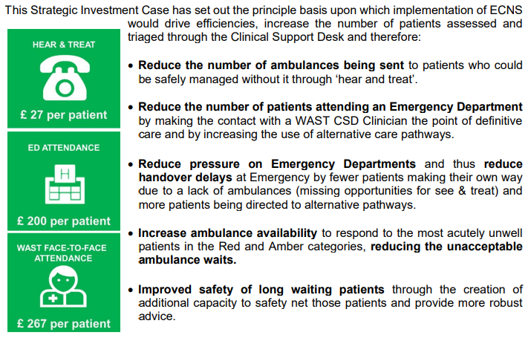

In addition to the above the additional 36 WTE combined with the reduced call cycle time provided by ECNS provide the opportunity for 60-70% of all 999 calls to receive a secondary clinical assessment prior to dispatch, this will not only increase patient safety and reduce clinical risk, but also significantly increase the opportunity for alternative care provision to be provided.

Does this promote the spread (innovation) from last year’s project? )
How does this proposal align with the deliverables and quality statements for the goal(s)?

This proposal is at the heart of the Goal 4 delivery, front loading the 999 system with enhanced clinical assessment is the enabler to delivery of the Goal outcomes.
This proposal would also deliver one of the key aspects of the clinical model innovation implemented in 2015, and put Wales on a path to being the world leader in delivering a clinically excellent ambulance service.
Please confirm the approval process for the investment.
Has this been considered by the relevant goal delivery group?
How was this proposal generated?
A business case was produced by the Welsh Ambulance Services NHS Trust in 2021/22. Year 1 of the case has previously been supported.

What is the evidence base?

ECNS offers more than 250 algorithms to support the clinician to assess the patient and record the answers to the questions asked to form an assessment summary and suggest a proposed outcome, which the clinician then decides upon.

The triage algorithms, which promote critical clinical thinking, are all evidence-based, fully references, and are maintained by a team of expert telephone triage doctors, nurses, and allied health professionals.

They conform to five key principles:
1) The provision of self-care instructions and the structured ruling out of serious conditions is key to ensuring that patients are not needlessly sent to A&E departments but that A&Es are not overburdened with patients not suitable for them.
2) All ECNS users can act as a positive gateway for caller education. ECNS is not a diagnostic tool but a consultation tool. ECNS should consult the patient to reach the most evidencebased suitable outcome and not solely triage them to an alternative provider.
3) ECNS algorithms aim to provide appropriate and maximal information support for clinicians to make evidence-based decisions with confidence.
4) ECNS algorithms do not replace the need for physical examination; if required.
5) ECNS algorithms are designed for maximal customizability and can be altered in dozens of ways to support the organisation using them and the data capture required.

Has this proposal been approved by the relevant Six Goals Programme mechanism (e.g. via the governance structure for the goal(s) to which it relates?
Yes – via Stephen Harrhy Goal 4 Lead

What investment do you estimate you will need for this project and what will it be spent on?

£250k – this is the cost of the annual licensing and ICT requirements for the ECNS system.
£1.8m – For the backfill costs of the 36 WTE clinicians temporally providing additional capacity to the clinical support desk, this funding will enable to the recruitment of additional staff to fill response rosters in 2022/23, enabling that additional CSD staff to provide more remote clinical assessment and an essential safety mechanism for patients awaiting an ambulance.

Prioritisation Criteria

Criteria & Weighting: Evidence:
- Ensuring patients accessing the 999 system receive the right response regardless of the reason they called 999 is a core component of the Six Goals.
- Enhancing ambulance remote assessment provides benefits for a number of the Goals and wider system.
Programme maturity

This will support the development / delivery of the Six Goals for Urgent and Emergency Care programme.

Scale

The investment supports a scalable change programme at project and / or programme level
- The investment would significantly increase the number of patients receiving a remote clinical assessment before ambulance dispatch, the impact of this has potential to benefit the whole Urgent and Emergency care system.

- The implementation of ECNS is key to the long term delivery of ambulance services in Wales, the system savings and improvement to patient safety and clinical risk provided by enhaincing the remote assessment capacity of the ambulance service will more than outweigh the cost of the system.
Sustainability

The project is clinically, operationally and financially sustainable in the long term, with supporting evidence that the project will become self-sufficient.

Prioritisation Criteria

Criteria & Weighting: Evidence:

- Safe and effective remote clinical assessment of patients accessing the 999 system support a number of the programme priorities across multiple Goals.
Delivery Milestones

The investment supports the delivery of the 2022/23 programme priorities

- The care and quality of care currently delivered to patients accessing the 999 system is unacceptable, the proposal is an effective and proportionate response to the current and likely ongoing system challenges.
- The proposal will contribute to quality statements within every Goal.
Care & Quality

The project will achieve significant, measurable improvement in the safety, quality and experience of care for the target cohort, with a strong clinical evidence base.
Please confirm which quality statements this project will contribute towards/ deliver?

- Deployment of ambulances and conveyance to emergency departments is a significant cost to NHS Wales.
- This proposal will ensure only those with the clinical need for such a response receive it, whilst also supporting the deployment or redirection to alternatives being developed within the Six Goals.
Finance & Efficiency

The project will either remove cost from the system, increase revenue, reduce future additional demand or improve efficiency

Project Evaluation
Patient experience (i.e. consider including patient survey)

ECNS provides the opportunity to ‘chat’ with the patient using text in addition to verbal communication to assist with that understanding. Additionally, the system enables advice to be sent via either SMS and/or email, enabling the patient to refer back to the advice. Given that ECNS has both the functionality to send worsening instructions and collect patient IDs such as NHS numbers, it is possible to also send patients a user experience survey link. While this direct approach has limitations in terms of data collection, it provides a new opportunity to allow the patient to share their experience of secondary telephone triage for the first time in WAST 999.
The system provides:
- Key Performance Indicators for remote clinical care
- Real-time data on dispositions, referral rates, and outcomes
- Real-time data on Hear & Treat rates per clinician per centre.
- Average call time call to triage time and call to disposition time.
- A database of calls for random call audit
- Digitally automated identification of themes and trends
- Individual, centre, and organisation clinical outcome metrics
- System that allows easy pan wales access to clinical audit data
- System that allows easy pan wales access for audit levelling
- Digital integration for video consultation
- Pandemic and seasonal flu capabilities
- Legal and clinical governance protection and support
- A pathway for accreditation as a centre of excellence

How will the investment be evaluated:

- Key deliverables
- Metrics
- Activity shift
- Quality measures

Project / investment spend

Non-recurrent expenditure:
£1.8m for temporary back fill of 36 WTE for expansion of the CSD in 2022/23 whilst wider system improvements are delivered.

Recurrent expenditure:

£250k for the ongoing licensing and ICT costs of the system

Exit strategy – what, if successful will the exit strategy be?

Business case for local investment or funded via released savings: Dependent on wider system improvements

Business case for national investment: Dependent on wider system improvements

Other investment external to Six Goals programme: Dependent on wider system improvements

Project end date: N/A

